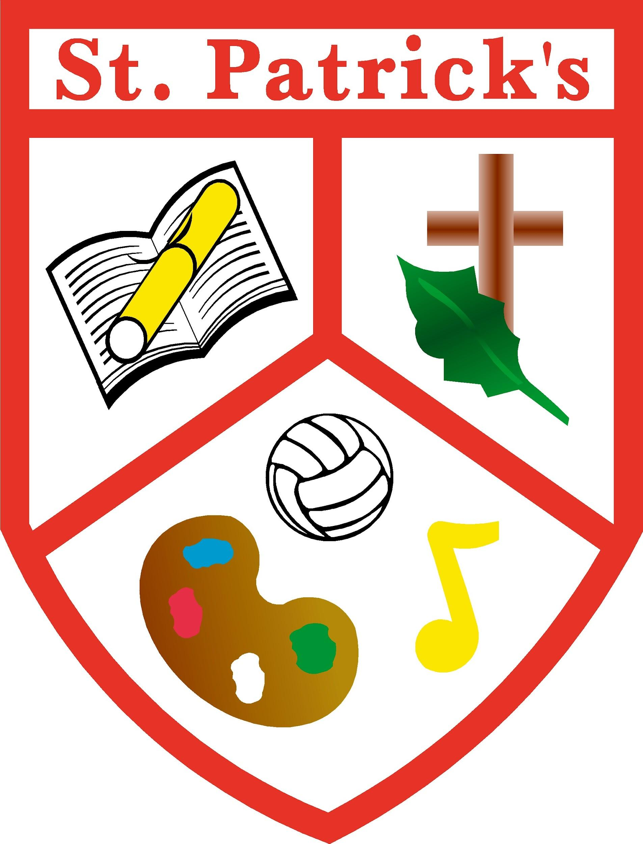

Saint Patrick’s Primary School,

Gilroy Avenue,

Edenderry,

Co.Offaly

Phone/Fax 046 9731478

Email: [office@stpatricksedenderry.ie](mailto:office@stpatricksedenderry.ie)

Website: [www.stpatricksedenderry.ie](http://www.stpatricksedenderry.ie)

Roll Number: 18364O

Register Charity Number: 20132972



*Principal: Ms. Ann Bracken Acting Deputy Principal: Mrs. Yvonne Martin*

**School Calendar 2025 - 2026**

**Term 1**

**Return to School:** Wednesday 27th August 2025

**Halloween break:**Closing: Thursday 23rd October.

Re-opening: Monday 3rd November

**Presidential Election**  Friday 24th October – School Closed

**Christmas Holidays:**  Closing: Friday 19th December

**Term 2**

**Return to School** Monday 5th January 2026

**February Bank Holiday:** Closed Monday 2nd February

**Spring Mid-Term:** Closed Thursday 19th and Friday 20th February

**School Closure** Curriculum Training Wednesday 25th February

**March Holiday:**  Closed Monday 16th and Tuesday 17th March

**Easter Holidays:**  Closing Friday 27th March.

**Term 3**

**Return to School:**  Monday 13th April

**May Bank Holiday:** Closed week of 4th May

Re-opening Monday 11th May

**School Closure** Curriculum Training Tuesday 19th May

**June Bank Holiday**: Closed on Monday 1st June

**Summer Holidays:**  Closing on Friday 26th June