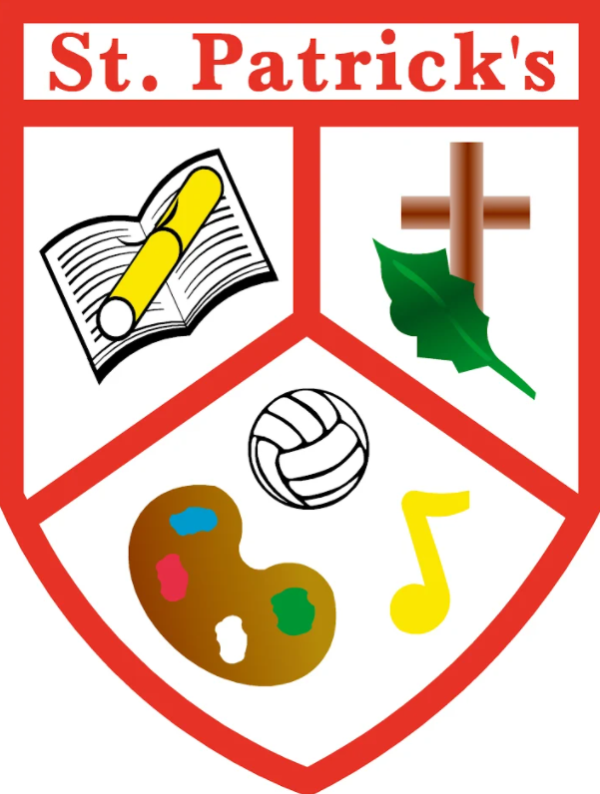
Saint Patrick’s Primary School,
Gilroy Avenue,
Edenderry,
Phone: 046 97 31478
Email: office@stpatricksedenderry.ie
Website: www.stpatricksedenderry.ie

23rd September 2022
Welcome to Our Newsletter!

Dear Parents,

On behalf of all our staff and Board of Management I warmly welcome all of our students back to school. In particular we are delighted to welcome our new Junior Infant boys and girls to our school. We are hoping that this year brings a more normal year than the last 2 school years and we look forward to an enjoyable positive year ahead.

Nicola McMahon
Principal
New Staff

We are delighted to welcome a number of new staff to the school this year. Miss Emma Brady has returned to our school after spending a year with us in 2019 and is teaching 4th class. Miss Emma Murray is teaching Senior Infants this year. Miss Ríona Byrne and Miss Michelle McInerney have also joined our staff and will take up roles as Special Education Teachers. Ken Slevin was appointed as our new caretaker before the summer holidays also. We also welcome Sinead Fennessy and Lorraine Callan who have joined our staff as Special Needs Assistants. We are delighted to welcome them all to our school staff.

Coaching in School
We are delighted to have athletics and gaelic games coaching through Edenderry GAA and Offaly Sports Partnership. All coaching sessions will take place with our coaches Mairead Daly of Edenderry GAA and Liam O Reilly of Offaly Sports Partnership. Mairead will be working with all of our classes from Junior Infants to 2nd Class on Thursdays. Liam will be completing athletics coaching with 3rd to 6th classes on Tuesdays.
School Lunches  School Lunches are now being provided to all students in the school as part of the School Meals Programme. Children receive a sandwich/roll and a piece of fruit each day. If your child would like additional food for their lunch please ensure to send it in with them.  If your child does not wish to receive these lunches you can cancel their order through The Lunch Bag app. | Home School Community Liaison  Mrs Yvonne Loughlin has taken up the role of Home School Community Liaison (HSCL) in our school. She looks forward to working in partnership with parents, teachers and local community organisations to support positive educational outcomes for pupils in our school.  She has organised a coffee morning in conjunction with our Parents Association for September 30th to provide an opportunity for parents of new students in our school to meet.
Book Rental  Please note that throughout the year we conduct a number of checks to ensure book rental books are kept in good condition. Any lost of damaged books must be replaced.  School Fees  There are still a number of families who have not paid book rental & school fees. Please ensure payment is made by September 30th. Fees can also be paid off in installments, please contact the office to arrange this. | Absences  Under the Education Welfare Act all absences must be explained. The best way parents can inform the school of an absence is through the Aladdin App. Alternatively a written note can be sent in to your child’s teacher to explain an absence.
Miss Cooney Departs  We would like to wish Miss Cooney the very best of luck in her future teaching career after she secured a new job in another school. Miss Cooney has taught Junior Infants in our school for the past 5years and she will be missed greatly by pupils and teachers alike. She will be remaining with us until October 6th before taking up her new post.  Junior Infants will be taught by Miss Ríona Byrne following her departure. Miss Byrne has been working closely with our Junior Infant class during September and we are sure that the transition to a new teacher will be as smooth as possible for all our young girls and boys. | Unwanted Toy Donation  Our Junior and Senior Infant classes will be using our Aistear Playroom from next week, October 3rd. We are asking parents to donate some of the following unwanted toys that are in good condition:  - Doll and doll accessories (clothes, prams, high chairs)  - Lego  - Cashier’s tills, baskets or trollies  - Doll house furniture and people  - Farm animals  - Play kitchen and/or kitchenware  - Puppets  - Dress Up Clothes
School Notices
- Please be advised that the gates will open from 9.10am, supervision for pupils will be provided from this time. In the interest of safety we ask that children do not arrive before this time. The Board of Management cannot accept responsibility for any children who arrive before this time.
- Please ensure all jumpers, coats and other belongings are clearly labelled with your child’s name. Already we have a number of jumpers that have been mislaid.
- All children being collected from school early must be signed out at the office.

Upcoming Events
- Coffee Morning on Friday September 30th at 9.30am in our school hall.
- School will close on Friday October 28th for Mid Term Break. It will reopen on Monday 7th November
- We will be dressing up for Halloween on Friday 28th October.
Welcome to our new Students!
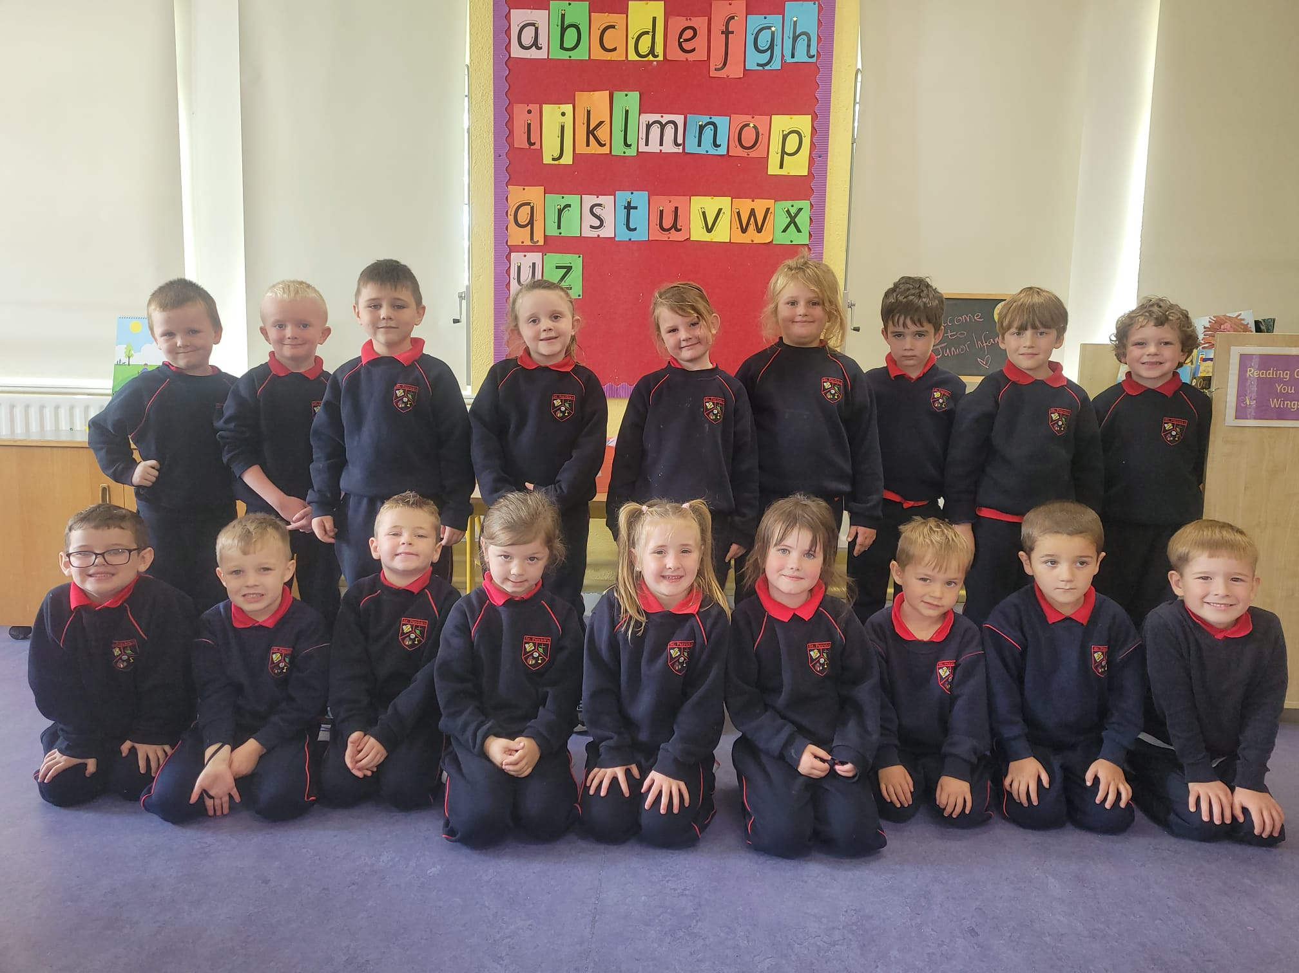
On 31st August we welcomed our new Junior Infants into our school. They have settled in so well and have been a wonderful addition to our school. We would like to take this opportunity to welcome both them and their parents to our school community. We look forward to working with you throughout their eight years in our school.

